myPass – Instructions to Create your Online Account

myPass.alberta.ca is a secure self-service website for Alberta Students. All high school students are required to sign up for this account. It will enable you to:

• Order high school transcripts

• View diploma exam marks

• Register to write or re-write diploma exams (with online payment)

• View and print Detailed Academic Reports (DAR)

• View progress towards a high school diploma

• View/Update your personal information

Before you begin you will need to have your **Alberta Student Number** (ASN), a personal email address, and your correct mailing address on file with Alberta Education. If you do not know your Alberta Student Number, ask the office or Ms. Hill to look it up for you or look at a recent report card. Make sure you use your ASN and **not** your student number from school. The ASN starts with a “1.”

**Instructions:**

1. Type “myPass.alberta.ca” in your browser.

2. Click on “Sign in with Education Account” (see below)

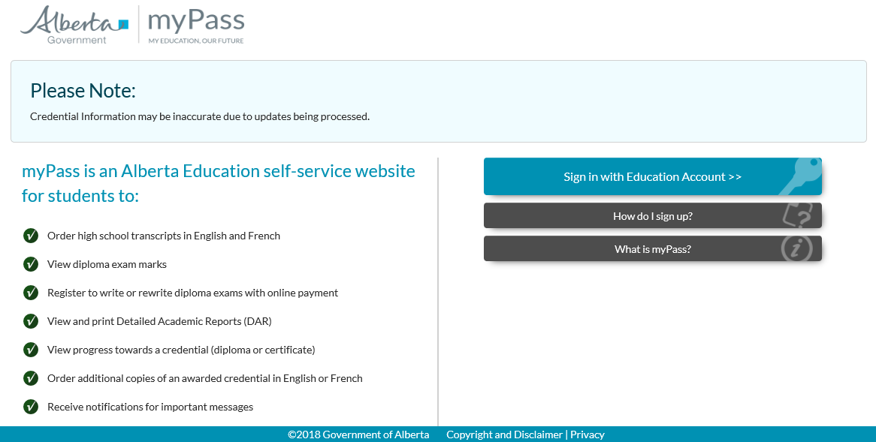

3. Sign in with your Google/Microsoft/GOA username/password and go to step 7.

**OR**

4. Fill in your email**. DO NOT use your School email**. Use a personal email.

5. Click “I’m new, sign me up!”

6. If asked, click, “I’m not a robot” and complete the task if needed (ie. Click all of the pictures with street signs.)

6. Click “SIGN IN”

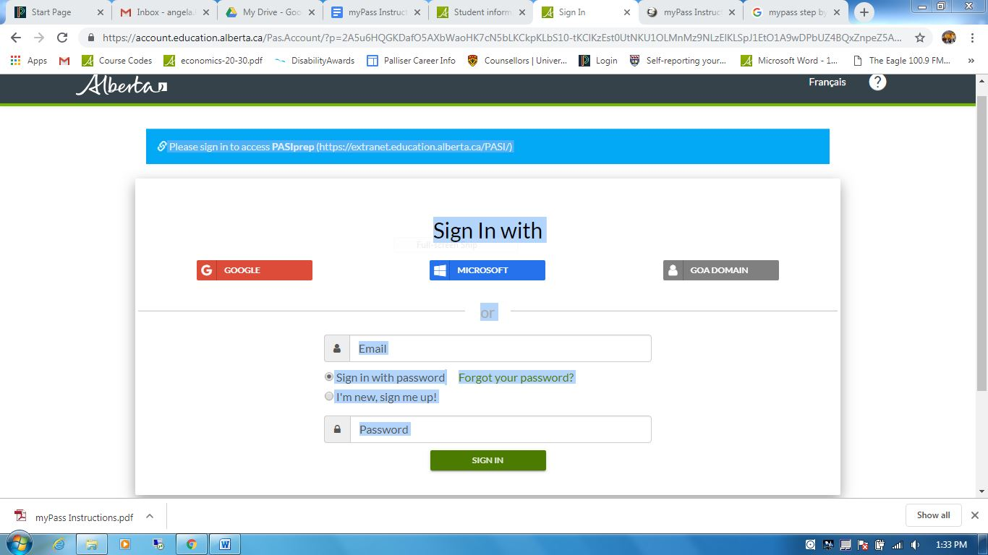

7. Fill in the required information. Check off “No” to the last question – “have you received a Signup Access Code?” Then Click “Activate Connection.”



8. Verify the info about your current address on the next screen and click on “Submit Connection Request.” If your address has changed recently you will need to update it.



9. The last screen will look like this:



You are finished for now. You will need to wait for Alberta Education to mail you a Signup Access Code.

Don’t forget to watch your mail delivery for an envelope addressed to you from Alberta Education.

**If you would like more information on what you can do with your myPass account or to watch a YouTube video about myPass and how to sign up, visit: <https://www.alberta.ca/student-information-high-school-transcripts.aspx?utm_source=redirector>