
Exceptional Education

Principal: Ms. Leanne Hellman B.Sc. Kin, B.Ed., M.A, M.Sc.
Vice-principal: Mrs. Lucy Thompson, B.A., B.Ed., M.Ed.
County Central High School
Box 390, 504 – 4th Avenue South
Vulcan, Alberta T0L 2B0
Phone: (403) 485-2223 Fax: (403) 485-2959

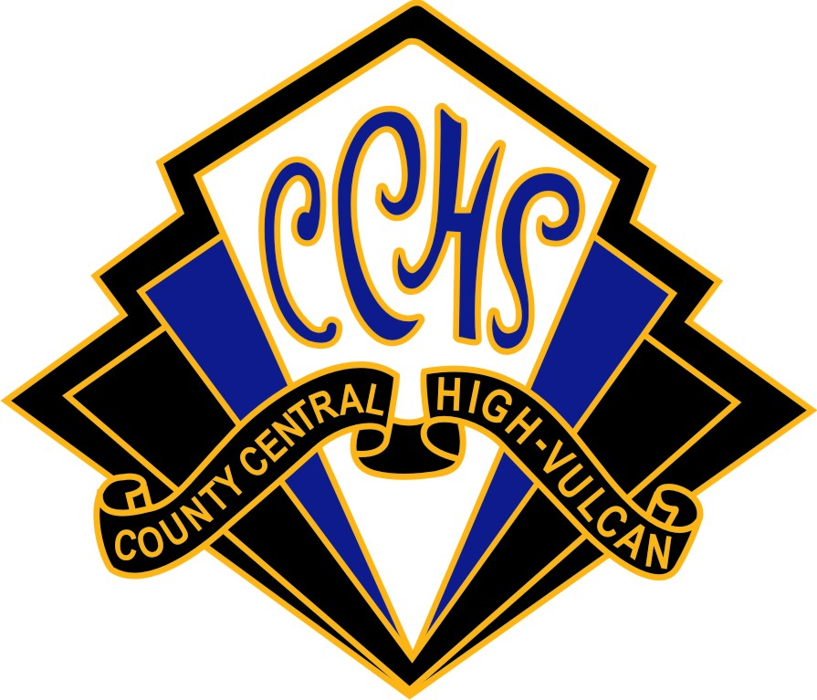

VOLUNTEER DRIVER
PARENT CONSENT FORM
Palliser Regional Division policy permits the use of properly licensed volunteer drivers as approved by the principal to convey students to and from off-campus activities. Under no circumstances are any students of CCHS to be used as volunteer drivers ( School Policy). Volunteer Drivers must be at least 21 years of age ( School and Palliser Policy).

Parental consent is required for a student to be a passenger in a vehicle driven by a volunteer for school sponsored off-campus activities.

The consent covers all off campus trips and activities within the current academic year.

Accordingly, please complete this form and return it to the school in care of the principal or athletic director.

I, __________________, agree that my son/daughter ________________ may travel to an
off –campus activity with a volunteer driver who has been approved by the CCHS administration .

_________________________ _______________
Student Signature Date
_________________________ _______________
Parent/Guardian Signature Date

